|  |
| --- |
| **Land Subsidence Analysis Using The DinSAR Method in Snap Application for The 2021 Periode** |
| **Mairizwan1, Hanifah Nur Ismail1,*, Joko Widodo2** |
| *1 Department of Physics, Universitas Negeri Padang, Padang 25131, Indonesia*  *2 Remote Sensing Research Centre, Aviation and Research Organization,, National Research and Innovation Agency (BRIN), Jakarta, 10340, Indonesia* |

|  |  |
| --- | --- |
| **Article History**  Received : September, 14th 2023  Revised : September, 23rd 2023  Accepted : September, 25th 2023  Published : September, 30th 2023  **DOI:**  https://doi.org/10.24036/jeap.v1i2.14  **Corresponding Author**  *Author Name: Hanifah Nur Ismail  Email: hanifahnurismail@gmail.com | Abstract: Three main factors can accelerate the rate of land subsidence, including: natural conditions (geology), groundwater extraction and building mass. Excessive groundwater extraction is believed to be one of the main factors leading to land subsidence. This occurs because there are still many DKI Jakarta residents who have not switched to using PAM RT water (Household Drinking Water Management). Data processing to obtain information in the form of the value of the range of subsidence of the DKI Jakarta area during 2021. The data taken in the form of Sentinel 1A data is then analyzed with the SNAP application using the Differential Interferometry Synthetic Aperture Radar (DInSAR) method. This research is useful to determine the rate of land subsidence in the DKI Jakarta area in 2021. Based on the results of data processing that has been done using the DInSAR method in the ESA SNAP application using Sentinel 1A imagery with data for the DKI Jakarta area in 2021, it can be concluded that for one year in 2021 the results of the decline in the area are -0.7 cm - -2.3 cm which is located near the Jakarta sea waters for one year in 2021. **Keywords:** Land Subsidence, DInSAR, SNAP |

|  |  |
| --- | --- |
|  | Journal of Experimental and Applied Physics is an open access article licensed under a Creative Commons Attribution ShareAlike 4.0 International License which permits unrestricted use, distribution, and reproduction in any medium, provided the original work is properly cited. ©2023 by author. |

# Introduction

DKI Jakarta as an Indonesian urban metropolis with a land area of 664.01 km2 is inhabited by around 10,562,088 people in 2020[3]. Based on the cause, there are three main factors that can accelerate land subsidence, including: natural (geological) factors; groundwater withdrawal factors; and building mass factors. Excessive groundwater extraction is believed to be one of the main factors leading to land subsidence. This happens because there are still many DKI Jakarta residents who have not switched to using PAM RT (Household Drinking Water Management) water [1].

Land Subsidence is the vertical change or deformation of the earth's surface in response to geological or anthropogenic aspects [2]. Slow or sudden subsidence of the land occurs at several centimeters per year. Such subsidence on the earth's surface is usually followed by physical changes that are clearly recognizable by their magnitude and speed of retreat. However, in the case of gradual subsidence, which is felt slowly after a long event, the rate of subsidence can be determined by a periodic mechanism [3].

Land subsidence can result from the growing demand for groundwater and the ongoing population expansion [9]. Land subsidence is common in large cities due to increased water requirements in urban areas and water pumping activities through aquifers [4]. Excessive use of groundwater is mostly carried out in zones with the aquifer potential, the more potential aquifer zones are found, the more storage wells around the area, making it vulnerable to land subsidence [5]. According to [7] in his research mentioned that after the dry season, subsidence increases, this is followed by increasing temperatures and groundwater extraction activities. Whereas during the rainy season, subsidence appears to decrease. It can be concluded that the value of non-linear subsidence decreases with seasonal variations.

By looking at the factors that cause subsidence in the DKI Jakarta area, namely natural factors (geology), soil extraction factors, and building mass factors. The excessive groundwater extraction factor is believed to be one of the main factors that cause land subsidence the main factor that causes land subsidence. This happens because there are still many DKI Jakarta residents who have not switched to using PAM RT (household drinking water management) water [1] and several other factors such as excessive groundwater mining activities, land use changes, uncontrolled development, and geological and hydrological conditions that allow subsidence. So data processing was carried out to obtain information in the form of the value of the subsidence range of the DKI Jakarta area that occurred during 2021. The data taken in the form of Sentinel 1A data is then processed using the SNAP application with the Differential Interferometry Synthetic Aperture Radar (DInSAR) method.

SNAP (Sentinel Application Platform) is software designed specifically for processing imagery from the Sentinel satellites, including Sentinel-1, Sentinel-2 and Sentinel-3 Toolbox. It is also capable of processing imagery from other satellites. The advantages of SNAP are 1). It can display satellite imagery very quickly, even for imagery with large storage sizes such as giga-pixel; 2). Reliable layer management that allows the addition and manipulation of overlays of various data; 3). Accurate reprojection and ortho-rectification process; 4). Can be used for geo-coding and rectification process using ground control points (GCP); 5). Can download the SRTM DEM for free according to the desired region. After processing the imagery from the Sentinel satellites using the SNAP software, the next step was to map the area of DKI Jakarta and its surroundings. This was done using Google Earth software.

Study by [1] the results show that the DKI Jakarta area experienced a reduction in size over a span of two years (2016-2017), with an annual decrease of -7.2 cm. This decline can be attributed to several key factors, primarily geological factors, specifically the presence of highly deformable alluvial deposits, as well as the impact of building mass loading and groundwater extraction. The final data show on Arcgis for mapping. This study still uses the DInSAR method with a different year period and the output is displayed on Google Earth.

The use of the DInSAR method in processing land subsidence data. The DInSAR technique, which stands for Differential Interferometric Synthetic Aperture Radar, represents one of the radar technologies employed for mapping subsidence regions. It possesses the capability to rapidly assess extensive areas with high precision [9]. Data obtained from land subsidence observations with accuracy in centimeters (cm). The use of this method is because of the small expenditure (open source) with the SNAP application tool and represented in Google Earth. Using the utilization of Sentinel 1A images with the DInSAR method can help accelerate the analysis and estimation of land subsidence rates. The method used in this research is DInSAR Two Pass Interferometry by utilizing two images that have different recording times, namely on January 4th, 2021 - December 30th, 2021.

# Materials and Method

The interferometric phase of each SAR image pixel will only depend on the difference in the path of travel of each of the two SARs to the considered resolution cell. In addition, the computed interferogram contains phase variations, the phase of the Earth's surface $ϕ_{flat}$ (some contributing factors such as the Earth's phase/curvature), the phase of the topography $ϕ_{DEM}$ (the topography of the Earth's surface), the atmospheric conditions $ϕ_{atm}$ (temperature, and pressure changes between the two acquisitions), and the noise $ϕ_{noise}$ (changes in spew, angle difference and spew volume) and finally the surface deformation $ϕ_{disp}$ that occurred between the acquisitions.

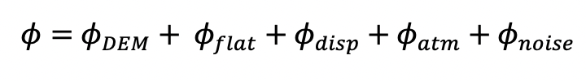 (1)

Differential SAR interferometry is used to estimate the earth surface subsidence subsidence $ϕ_{flat}$ and $ϕ_{DEM}$ which are considered the same for both image acquisitions and remove them from the interferogram so that the remaining phase variations can be attributed to the surface elevation changes between the two images acquisitions. So to get the deformation effect, the differential interferometry method must be done or by differentiating the 2 interferograms and removing the influence of topography, noise, and atmosphere.

In addition to the interferometric phase coherence between the reference and secondary images by estimating indicators for the quality of the base information. Basically, it indicates if the images have strong similarity therefore used for interferometric processing, loss of coherence can result in poor interferometric results due to temporal (vegetation and water bodies), geometric (errors or mismatches in the metaorbit). So to get the deformation effect, the differential interferomtery method must be done or by differentiating the 2 interferograms and removing the influence of topography, noise, and atmosphere.

The data is processed using the interferogram method after inputting the data. In the interferogram formation display, subtract flat-earth phase, subtract topographic phase, include coherence estimation and most importantly use back geocoding with DEM SRTM 1 sec the process steps of data processing from start to analysis are illustrated in the Figure 1 below:

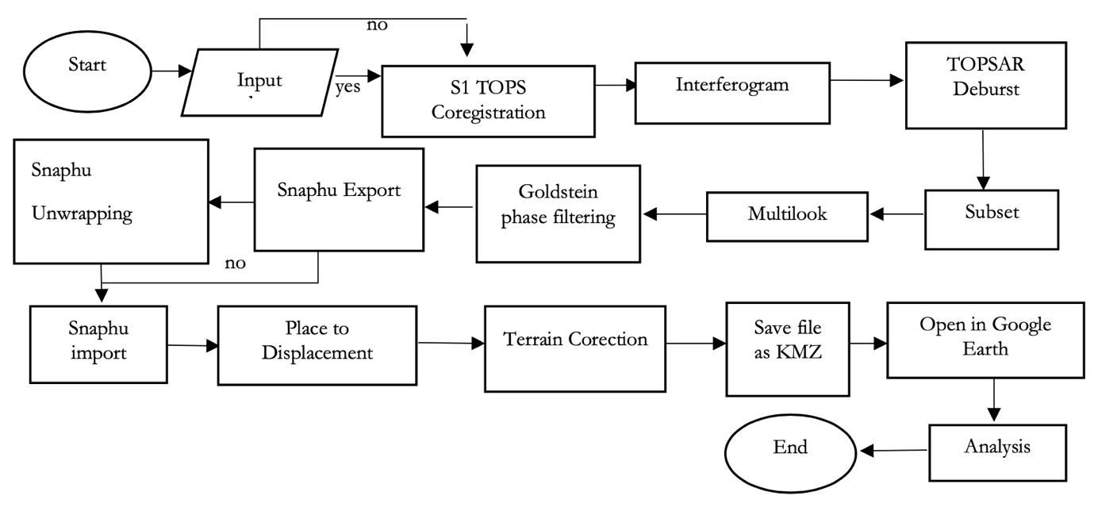

Figure 1. Data Processing Flowchart

Based on Figure 1 the process the data processing begins with the preparation phase, where satellite radar data is collected for two different time periods. The data get from the website scihub Copernicus with Single Look Complex (SLC) data specifications, VV+VH Polarization, Decending Method, in the range of January 1 - December 31, 2021. Data Input retrieved from the satellite, including the radar data from the two observation periods, is used as input in the processing. S1 TOPS Coregistration where two radar images from different times are set in the right position to minimize the position and rotation differences. In this case TopSAR-Split is useful to select data only in bursts needed for analysis (subswath: IW3, polarizations: VV, bursts: 1-4) by Back-Geocoding with DEM (digital elevation model) SRTM 1 sec and bilinear interpolation method which aims to increase or decrease the number of pixels in digital images so as to produce good images. After coregistration, the steps is Interferogram, the two radar images are used to create an interferogram image, which shows the phase change of the radar waves between two observation periods. This helps in identifying changes in the distance of the earth's surface.

TOPSAR Deburst, this process converts radar data that has a burst format into more structured and processable data. Bursts are sections of radar data that are taken over a short period. Subset is the selection of certain regions of the interferogram image for further processing. Multilook is the process of combining multiple pixels in the image to improve spatial resolution and reduce noise. The next steps, Goldstein Phase Filtering, this process applies a phase filtration technique based on the Goldstein method to remove noise and artifacts from the interferogram image. SNAPHU Export, Snaphu Unwrapping, SNAPHU, A phase unwrapping process is performed on the interferogram image to obtain more precise displacement data. Place to Displacement the phase data that has been parsed is then converted into displacement data, which represents the change in distance of the earth's surface between two observation periods. Next, Terrain Correction, this process involves correcting the effects of topography on the data, so that the observed surface changes are not affected by topographic height differences. Save as File as KMZ.

The final result of the data processing is saved in KMZ format, which allows the data to be accessed and visualized using the Google Earth application. The final steps are Opening in Google Earth, the resulting KMZ file can be opened in Google Earth, enabling more interactive visualization and analysis and easier understanding of the Earth's surface changes in the observed area. Analysis, the processed KMZ files opened in Google Earth are used to perform further analysis and obtain important information about the land surface changes in the observed area. This analysis helps in understanding geological and environmental phenomena that are relevant and valuable for various scientific and practical applications

# Results and Discussion

1. *Result from Data Processing*

S-1 TOPS Coregistration, master and slave intensity comparison of the data. The master and slave in this data are recorded from two different times on the same object on the earth's surface. The master in this data is a SAR image that was taken earlier than the slave image. Coregistration is the process of aligning images from different times so that accurate temporal and interferometric analysis can be performed. The result of coregration is an increase or decrease in the number of pixels in a digital image so that the image is better.

Interferograms, using SRTM 1sec HGT and the addition of formation phase, topographic, and coherence obtained phase differences in data pairs (master and slave). Radar interferometry (interferogram) is a technique that uses two S-1 radar images taken at different times to detect changes in the Earth's surface. By comparing the phase of the radar waves between the two images, interferograms can provide information about ground movement, deformation and other geological activity. The results obtained are the phase difference before interferometry of flattened pixels see in Figure 2.

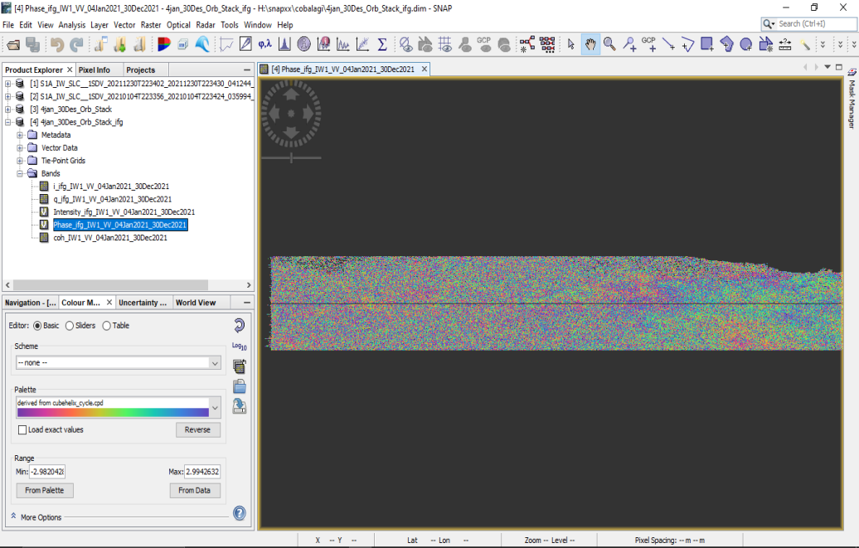

Figure 2. Result of Interferogram Process

Based on Figure 2, the main output of the interferogram process is an interferogram image obtained by combining the phase information (waveform changes) of two SAR satellite images taken at different times. This interferogram image shows a color pattern that reflects the difference in relative distance between the ground surfaces at the two acquisition times. In the interferogram image, there is a pattern of broken lines known as "fringes" that represent surface deformation. Each color in the fringe indicates the change in relative distance that occurred. For example, red indicates upward movement (uplift), while blue indicates downward movement (subsidence).

Goldstein phase filtering reduces the influence of phase noise on SAR interferometric images and improves the accuracy of ground deformation measurements. These results can help produce more accurate ground deformation maps by reducing the influence of noise on the image. By using more accurate ground deformation maps, we can better monitor land surface changes and identify deformation patterns that may be related to geological activities or environmental changes (Figure 3).

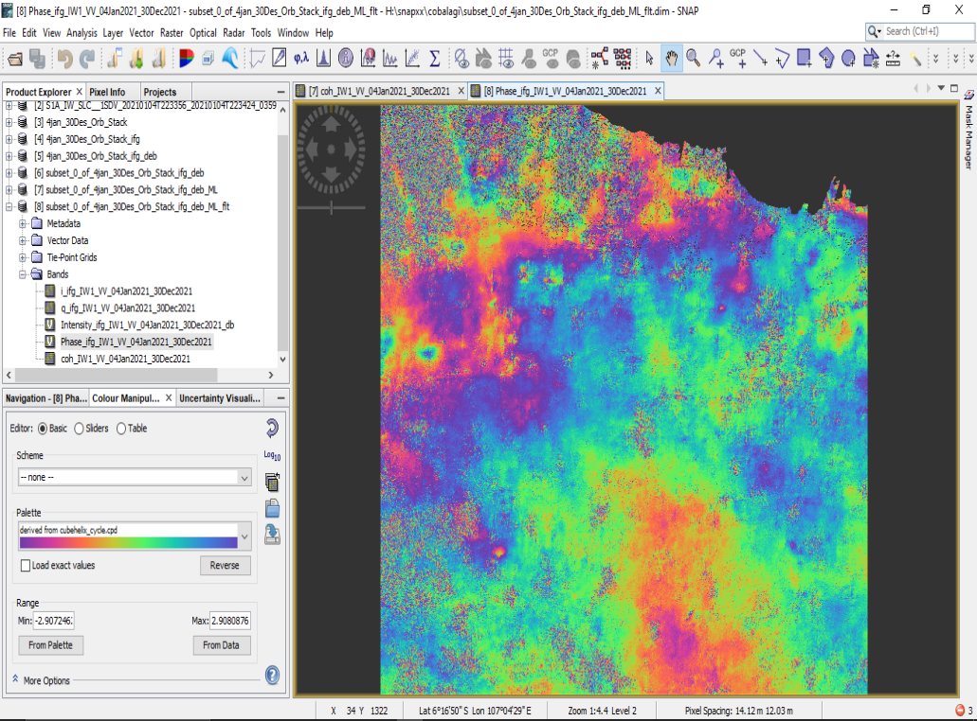

Figure 3. Result of Process Goldstein Phase Filtering

After that, Unwrapping with input the last data Snaphu Unwrapping produces continuous phase maps, which can be interpreted as changes in ground level. These maps are often referred to as "interferometric maps" or "interference maps". Using this map, it is possible to identify and quantitatively measure subsidence or ground deformation (Figure 4).

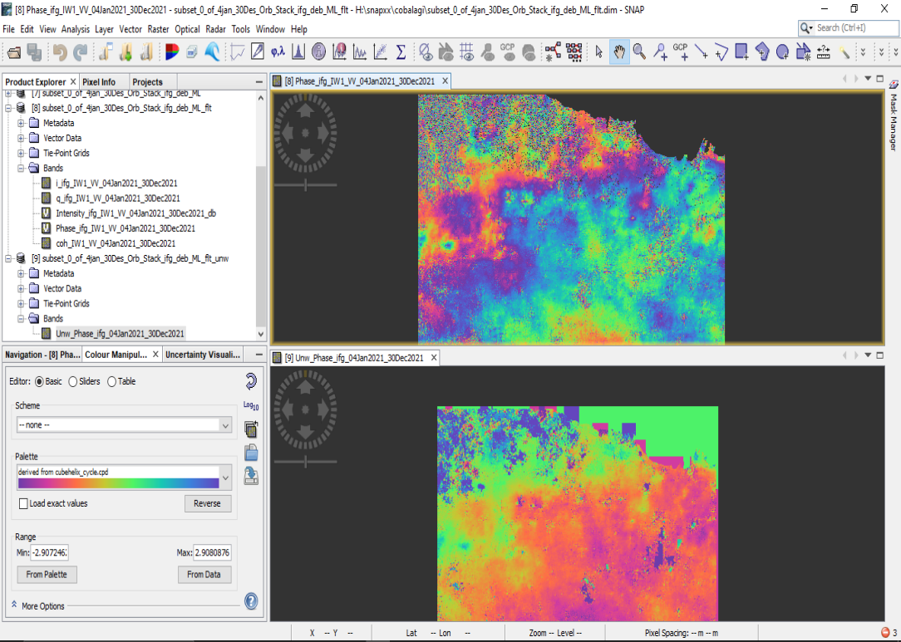

Figure 4. Phase Data Processing Results before Unwrapping and After Unwrapping

Next step is Phase to Displacement, a result obtained to view land subsidence that shows the pattern of subsidence or land uplift in the observed area. This map can help identify areas that experience subsidence or land surface rise, as well as map the pattern of deformation that occurs. In addition, the Place to Displacement stage can also provide information on the speed and direction of ground movement in the observed area, which can help estimate the risk of damage to buildings and infrastructure in the area. The final step is Open in Google Earth with file format as KMZ (Figure 5).

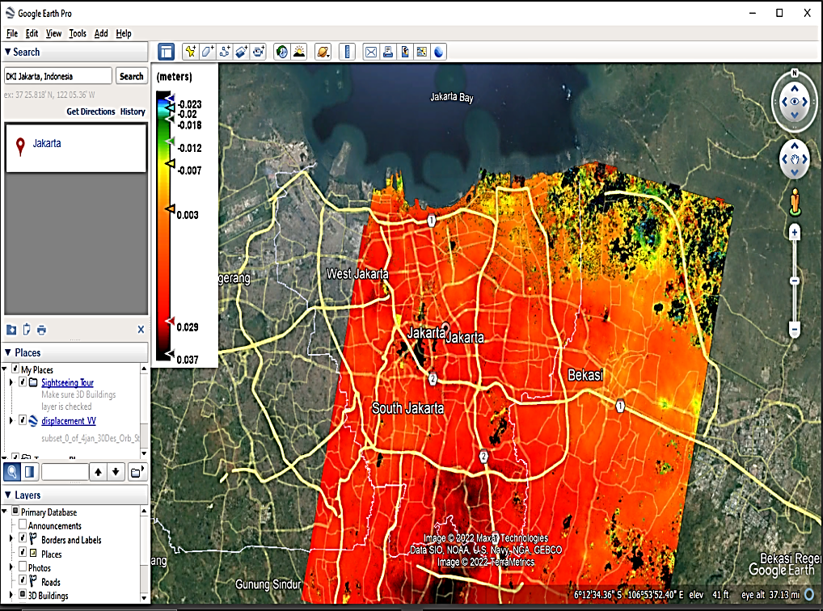

Figure 5. Result Data after Open in Google Earth

The results of land subsidence data processing based on Figure 3 in the DKI Jakarta area show significant variations in land subsidence rates, ranging from -0.007 meters to -0.023 meters or in centimeters -0.7 cm/year to -2.3 cm/year. In the processed images, areas with subsidence rates around -0.7 cm/year are usually shown in orange, indicating moderate subsidence. However, areas with more extensive subsidence rates, reaching -2.3 cm/year, are shown with darker colors such as black, indicating more significant subsidence and requiring more attention in risk management and mitigation. This information is important for stakeholders in the DKI Jakarta region to take appropriate action in addressing the impacts of land subsidence on infrastructure and the environment.

1. *Discussion*

A study conducted by I Putu Pudja in 2018 presents data on land subsidence in DKI Jakarta in two different years, namely 2016 and 2017. In 2016, the data showed a decline in the area of -12.55 cm/year, while in 2017 the decline reached -1.8 cm/year. These results illustrate a significant rate of decline within one year.

Furthermore, to update the latest information on the decline of DKI Jakarta, the latest data processing has been carried out in 2021. The results of this latest data processing show a wider variation in the level of subsidence, which ranges from -0.7 cm/year to -2.3 cm/year. This indicates that the problem of subsidence in this region is still an important issue that needs to be monitored regularly to understand the ongoing changes in land surface conditions.

The following table shows a comparison of DKI Jakarta subsidence data in 2016, 2017, and the latest data processing results in 2021 based on the sources mentioned on Table 1.

Table 1. Comparison of Land Subsidence

|  |  |  |  |
| --- | --- | --- | --- |
| **Region** | **Land Subsidence** | | |
| DKI Jakarta | 2016 | 2017 | 2021 |
| -12,5583418 cm/year | -1,8289 (~-1,8) cm/year | -0.7 cm - -2.3 cm/year |
| [1] | | [2] |

(Source : [1] I Putu Pudja, 2018. [2] data processing).

Land subsidence in Jakarta in 2016 was caused by various factors, such as excessive groundwater extraction, development on land that should not be built such as on swamp or sea, and uncontrolled land use change. This causes land in Jakarta to become lower and prone to flooding.

In 2017 Jakarta still experienced significant subsidence. Some areas affected by subsidence include North Jakarta, West Jakarta, South Jakarta, and East Jakarta. This subsidence is still caused by some of the same factors as the previous year, such as excessive groundwater mining activities, increased building and infrastructure loads, and geological conditions that allow subsidence to occur.

In 2021, due to a number of factors, namely rising sea levels as a result of climate change and a number of other factors such as excessive groundwater extraction activities, land use change and development. climate change and several other factors such as excessive groundwater extraction, land-use change, uncontrolled development and geological and Mining activities, land-use change, uncontrolled development, and geological and hydrological conditions that allow the occurrence of uncontrolled development, and geological and hydrological conditions that allow the occurrence of uncontrolled development, and uncontrolled development and geological and hydrological conditions that allow land subsidence to occur.

A comparison between 2021 and 2016-2017 shows an interesting change. From 2016 to 2017, there was a very large decrease in the rate of subsidence, decreasing by about -10.7 cm per year. However, from 2017 to 2021, the subsidence rate experienced a more stable change, ranging from -0.7 cm to -2.3 cm per year. This could indicate a change in the factors affecting subsidence between 2016-2017 and 2021.

To overcome the problem of land subsidence, the government has made various efforts, such as better groundwater management, the application of technology to monitor changes in land surface, and increasing public awareness about the importance of protecting and preserving the environment. However, the problem of land subsidence in Jakarta is complex and ongoing. Therefore, more integrated and sustainable efforts are needed in groundwater management and overall environmental governance, as well as the application of more sophisticated and innovative technologies to monitor and control future land subsidence changes. With these suggestions and recommendations, it is hoped that it can help the government and the community to reduce the problem of subsidence in the DKI Jakarta area. However, keep in mind that these efforts must be carried out jointly and continuously to achieve optimal results.

# Conclusion

Based on the results of data processing that has been carried out using the DInSAR method in the ESA SNAP application using Sentinel 1A imagery with data for the DKI Jakarta area in 2021, it can be concluded that for one year in 2021 the results of the decline in the area are -0.7 cm to -2.3 cm which is located near the Jakarta sea waters for one year in 2021. This occurs due to several factors, namely triggered by sea level rise as a result of climate change and several other factors such as excessive groundwater mining activities, land use changes, uncontrolled development, and geological and hydrological conditions that allow land subsidence. In addition, there is also the impact of land subsidence, as well as the special character of coastal Jakarta which is sloping and located in a bay and the existence of increased residential development in 2021.

**Acknowledgments**

I'd like to express my gratitude to my parents, the BRIN Institute (National Research and Innovation Agency) for Remote Sensing for imparting valuable knowledge about remote sensing, the EU Copernicus program for granting access to Sentinel-1A satellite data, the ESA SNAP forum for offering invaluable assistance during this research, and my friends for their unwavering support.

**References**

1. Pudja, C. I. (2018). Analysis of Land Subsidence in DKI Jakarta Using the Differential Interferometry Synthetic Aperture Radar (DInSAR) Method. Journal of Physics and Innovation in Physics, 2(2), 88–99, [Online].
2. Kuang, S. (1996). Geodetic Network Analysis and Optimal Design. Ann Arbor Press, Chelsea, Michigan.
3. BPS. (2020). BPS Provinsi DKI Jakarta,[Online]
4. Hadiyanto, E. H. (2011). Deformation Study of Mount Merapi Using Interferometry Synthetic Aperture Radar (InSAR) Technology. Surabaya: Geomatics Engineering, Sepuluh Nopember Institute of Technology.
5. Dang, V. K., et al. (2014). New Orleans Subsidence Caused by Rapid Urban Development in the Hanoi Region (Vietnam) using ALOS InSAR Data. Natural Hazard and Earth System Science, 14, 657–674.
6. Mochammad, M., & Saepuloh, A. (2017). Analysis of Surface Deformation with the SBAS InSAR Method and Its Correlation with Aquifer Occurrence in Surabaya City, East Java, Indonesia. IOP Conference Series.
7. Zhou, L., et al. (2017). Wuhan Surface Subsidence Analysis in 2015–2016 Based on Sentinel-1A Data by SBAS-InSAR. Remote Sensing, 8, 982.
8. Purna T. Pemanfaatan Metode InSAR untuk Pemantauan Deformasi Gunung Api dan Penurunan Tanah. Bandung: Teknik Geodesi dan Geomatika, Institut Teknologi Bandung. 2009.
9. Setiawan B, Akbar GDPN, Suyeda FD, Permana R. Analisa land subsidence dengan metoda DInSAR di kawasan geowisata Muara Dua Kabupaten Oku Selatan. Seminar Nasional AVoER XIV. 2022;1:294–300.
10. Hanssen RF. Radar Interferometry. Data Interpretation and Error Analysis. Kluwer Academic Publishers. The Netherlands: Delft University of Technology. 2001.
11. ESA. Sentinel1 User Handbook, [Online].
12. Elachi C, Zyl JV. Introduction to the Physics and Techniques of Remote Sensing. In: منشورات جامعة دمشق; 2006
13. Ramadhanis Z, Prasetyo Y, Yuwono BD. Spatial Correlation Analysis of the Impact of Land Subsidence on Flooding in Jakarta. J Geodesy UNDIP. 2017;6(3).
14. Minardi S, Hiden, Dahrin D, Yusuf M. Analysis of Groundwater Depletion and Land Subsidence Using Microgravity and Vertical Gradient Methods Over Time: A Case Study in Jakarta. Jurnal Ilmu Dasar. 2014;15(1).